**Preparation for Baptism or Thanksgiving for a child**

**Day, Date, Year**

**Time**

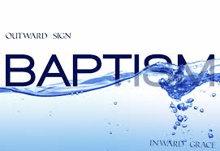

**Before baptism**

Page

1. Before Baptism
2. What is Holy baptism? 3
3. Signs of baptism 3
4. What is a Christian 4
5. What baptism is and what it is not 5
6. Pastoral introduction to Holy Baptism 5
7. Alternatives to Holy Baptism
8. Service of Thanksgiving for the gift of a child 6
9. After Baptism
10. Spiritual growth 9
11. Examples for growth 9
12. Prayer 10
13. Care 10
14. The service of Holy Baptism
15. Presentation of the candidates 11
16. The Decision 11
17. Profession of faith 12
18. Prayer over the Water 13
19. Baptism 13
20. Signing of the cross 13
21. The Welcome 13
22. The Commission 14
23. **Before Baptism**

**Introduction**

* What has God done in your life to bring you to this point?
* What is your experience of baptism?
* Why do you want your child baptized?

1. **What is Holy Baptism?**

A command

Matthew 28:18-20

A sign and seal

* Romans 4:11;
* Colossians 2:11-12

See also:

* Exodus 30:19-21
* Leviticus 14:7-9
* Ezekiel 36:25
* Matthew 3:13-17
* Hebrews 10:22

1. **Signs of Baptism**

|  |  |  |  |  |
| --- | --- | --- | --- | --- |
| **Union with Christ** |  |  |  | **Adoption** |
|  |  |  |  |  |
| **Forgiveness of sin** |  |  |  | **Washing away sin** |
|  |  | **Baptism** |  |  |
| **New life** |  |  |  | **Receive Holy Spirit** |
|  |  |  |  |  |
| **Membership of church** |  |  |  | **Walking in light** |

1. **What is a Christian?**

Nicene Creed (creed = statement of beliefs)

WE BELIEVE in one God, the Father, the Almighty, maker of heaven and earth, of all that is, seen and unseen.  
  
We believe in one Lord, Jesus Christ, the only Son of God, eternally begotten of the Father, God from God, Light from Light, true God from true God, begotten, not made, of one Being with the Father. Through him all things were made. For us and for our salvation he came down from heaven: by the power of the Holy Spirit he became incarnate from the Virgin Mary, and was made man. For our sake he was crucified under Pontius Pilate; he suffered death and was buried. On the third day he rose again in accordance with the Scriptures; he ascended into heaven and is seated at the right hand of the Father. He will come again in glory to judge the living and the dead, and his kingdom will have no end.  
  
We believe in the Holy Spirit, the Lord, the giver of life, who proceeds from the Father and the Son. With the Father and the Son he is worshiped and glorified. He has spoken through the Prophets. We believe in one holy catholic and apostolic Church. We acknowledge one baptism for the forgiveness of sins. We look for the resurrection of the dead, and the life of the world to come. AMEN.

1. **What Baptism is -**

**What Baptism isn’t:**

What does this mean for me and my faith?

1. **Pastoral Introduction to Baptism**

Baptism marks the beginning of a journey with God which continues for the rest of our lives, the first step in response to God’s love. For all involved, particularly the candidates but also parents, godparents and sponsors, it is a joyful moment when we rejoice in what God has done for us in Christ, making serious promises and declaring the faith. The wider community of the local church and friends welcome the new Christian, promising support and prayer for the future. Hearing and doing these things provides an opportunity to remember our own baptism and reflect on the progress made on that journey, which is now to be shared with this new member of the Church.

The service paints many vivid pictures of what happens on the Christian way. There is the sign of the cross, the badge of faith in the Christian journey, which reminds us of Christ’s death for us. Our ‘drowning’ in the water of baptism, where we believe we die to sin and are raised to new life, unites us to Christ’s dying and rising, a picture that can be brought home vividly by the way the baptism is administered. Water is also a sign of new life, as we are born again by water and the Spirit. This reminds us of Jesus’ baptism. And as a sign of that new life, there may be a lighted candle, a picture of the light of Christ conquering the darkness of evil. Everyone who is baptized walks in that light for the rest of their lives.

As you pray for the candidates, picture them with yourself and the whole Church throughout the ages, journeying into the fullness of God’s love.

Jesus said, “I came that they may have life, and have it abundantly.” John 10:10.

1. **Alternatives to Holy Baptism**

For some parents who do not feel ready to commit to a baptism, or in conscience prefer this

**What happens in a Thanksgiving Service?**

See pages 7 and 8

**Godparents**

Provide support and spiritual encouragement

What makes a good godparent?

What is the difference between a sponsor and a godparent?

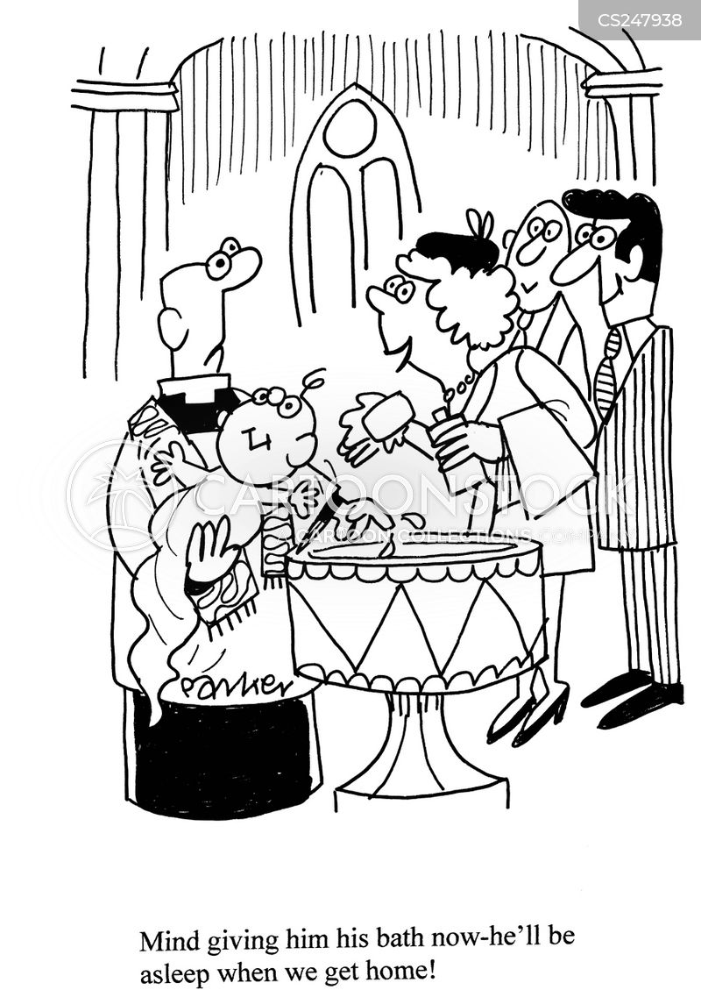

1. **Service of Thanksgiving for the gift of a Child**

Minister Do you receive this child as a gift from God?

**Parents We do.**

Minister Do you wish to give thanks to God and seek His blessing?

**Parents We do**

**Minister** God our creator, we thank you for the wonder of new life

and for the mystery of human love. We thank you for all

whose support and skill surround and sustain the

beginning of life We thank you that we are known to you

by name and loved by you from all eternity. We thank you

for Jesus Christ, who has opened to us the way of love. We

praise you, Father, Son, and Holy Spirit.

**All Blessed be God forever**

**Minister** As Jesus took children in his arms and blessed them, so now

we ask God’s blessing on …. Heavenly Father, we praise you

got his/her birth; surround him/ her with your blessing

that he/she may know your love, be protected from evil.

And know your goodness all his/her days.

**All May he/she learn to love all that is true, grow in wisdom**

**and strength, and, in due time, come through faith and**

**baptism to the fullness of your grace; through Jesus**

**Christ our Lord. Amen.**

**Minister** May God the Father of all bless these parents and give them grace to love and care for their children. May God give them wisdom, patience and faith, help them to provide for the child’s/children’s needs and, by their example, reveal the love and truth that are in Jesus Christ.

**All Amen.**

***Giving of the Gospel***

**Minister** Receive this book. It is the good news of God’s love. Take it as your guide.

**(To congregation)** Will you do all that you can to help and support this family?

**All With the help of God, we will.**

**All God our creator, we thank you for the gift of this child, entrusted to our care. May we be patient and understanding, ready to guide and to forgive, so that through our love she/he may come to know your love; through Jesus Christ our Lord. Amen.**

1. **After Baptism**
2. **Spiritual Growth**

* Ps 78:1—8: Parental responsibility.
* Church is there to help, not replace the parents’ role – especially in the teenage years.
* We need to help our children find their place within the life and worship of the Church family by making church a positive experience.
* All this helps our children make an informed choice about church as they grow into adulthood when their must decide for themselves whether to put into practice what their baptism symbolizes.

1. **Examples of growth**

* Note external influences: TV.
* Being a Christian every day.
* Being open with your children about your own faith – let your children see you reading the Bible and praying
* Help them to enjoy the Bible in age appropriate ways.
* Use Christian books and music.
* Say ‘grace’ before meals.
* Mark the anniversary of their baptism.
* Include godparents and grandparents.

1. **Prayer**

* Praying for our children; their
  + Character
  + Faith
  + Future
* Praying with our children;
  + At mealtimes
  + At bedtime
  + At key stages in their life

1. **Care**

* Models we inherit from our parents
* Child-centred vs marriage-centred
* The five love languages; affirming words; quality time; receiving gifts; practical service; physical touch
* Family values (10 commandments)
* Discipline (Proverbs 1: 7-9; 22:6)
* Deciding to be parents not just friends (Ephesians 6:1-4)

Recommended reading: **Family Time**

by Mark and Lindsay Melluish

1. **The Service of Holy Baptism**

**i.Presentation**

*The minister addresses the whole congregation:*

Faith is the gift of God to His people. In Baptism the LORD is adding to our number those whom He is calling. People of God, will you welcome ***NAME*** and uphold *her* in *her* new life in Christ?

**All: With the help of God, we will.**

*The minister addresses the parents and godparents:*

Parents and Godparents, the Church receives***NAME***with joy. Today we are trusting God for *her* growth in faith. Will you pray for *her*, draw *her* by your example into the community of faith, and walk with *her* in the way of Christ?

**With the help of God, we will.**

In Baptism, children begin their journey in faith. You speak for ***NAME***today. Will you care for *her* and help *her* to take *her* place within the life and worship of Christ’s Church?

**With the help of God, we will.**

**ii.The Decision:**

In Baptism, God calls us out of darkness into His marvellous light. To follow Christ means dying to sin and rising in new life with Him.

Therefore, I ask you:

Do you reject the devil and all rebellion against God?

**I reject them.**

Do you renounce the deceit and corruption of evil?

**I renounce them.**

Do you repent of the sins that separate us from God?

**I repent of them.**

Do you turn to Christ as Saviour?

**I turn to Christ.**

Do you submit to Christ as LORD?

**I submit to Christ.**

Do you come to Christ, the Way, the Truth and the Life?

**I come to Christ.**

*The minister addresses the whole congregation:*

**iii.Profession of Faith:**

Let us affirm, together with those who are being baptised, our common faith in Jesus Christ.

Do you believe and trust in God the Father, the source of all being and life, the one for whom we exist?

**All: I believe and trust in Him.**

Do you believe and trust in God the Son, who took our human nature, died for us and rose again?

**All: I believe and trust in Him.**

Do you believe and trust in God the Holy Spirit, who gives life to the people of God and makes Christ known in the world?

**All: I believe and trust in Him.**

This is the faith of the Church:

**All: This is our faith. We believe and trust in one God, Father, Son and Holy Spirit.**

*The Baptism party moves to the font.*

**iv.Prayer over the Water:**

Praise God who made heaven and earth.

**All: Who keeps His promise for ever.**

Let us give thanks to the LORD our God.

**All: It is right to give thanks and praise.**

*The minister then prays over the water.*

**v.Baptism**

***NAME****,* I baptise you in the name of the Father, and the Son, and the Holy Spirit.

**vi.Signing of the cross**

*The minister then makes the sign of the cross on the forehead, saying:*

Christ claims you for His own; receive this sign of His cross.

*The minister then says:*

***NAME*** do not be ashamed to confess the faith of Christ crucified.

**All: Fight valiantly, as a disciple of Christ, against sin, the world and the devil, and remain faithful to Christ to the end of your life.**

**vii.The Welcome:**

***NAME****,* there is one LORD, one faith, one baptism; by one Spirit we are all baptised into one body.

**All: We welcome you into the fellowship of faith; we are children of the same heavenly father; we welcome you.**

*The Baptism party moves back to the front of church with the minister carrying the newly baptized as everyone welcomes her into the Church. Then the minister says:*

To mark this momentous occasion, we would like to present you with two things: a Bible, and a candle representing Jesus, the light of the world.

**viii.The Commission**

**Giving of a Children’s Bible and then a candle:**

*The Youth and Children’s minister gives a Bible and then a lighted candle (to the parent(s)), and the minister says:*

God has delivered us from the dominion of darkness and has given us a place with the saints in light. ***NAME***, you have received the light of Christ; walk in this light all the days of your life.

**All: Shine as a light in the world to the glory of God the Father. Amen.**

*The congregation then clap and everyone sits back down.*

**What to do next**

Decide if baptism is appropriate, and possible date

Approach suitable godparents

Return the completed form available on the web-site

Make plans for after baptism – form good habits of life and prayer for your family.

St James’ church

Church Lane

Rowledge

Farnham

GU10 4EN

E: [admin@stjamesrowledge.org.uk](mailto:admin@stjamesrowledge.org.uk)

T: 01252 79240